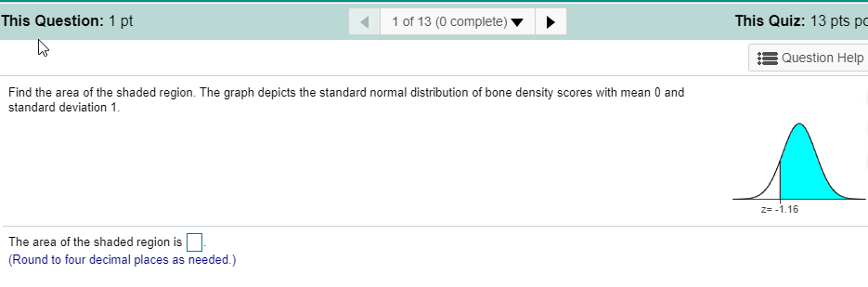

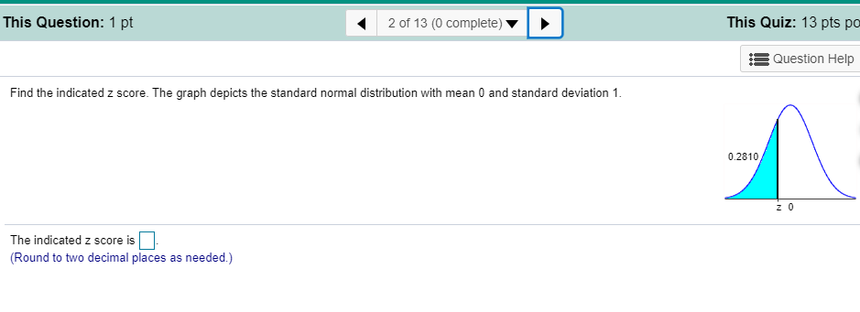

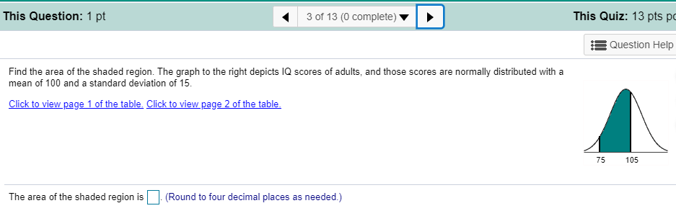

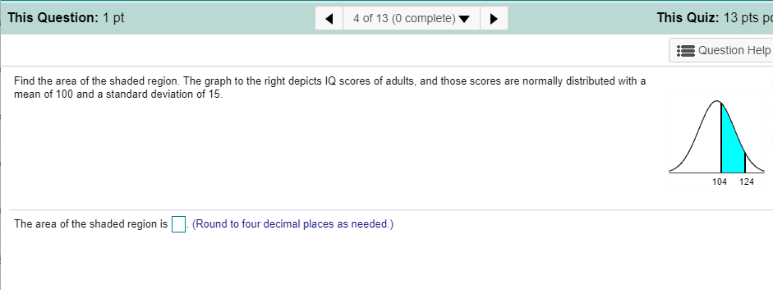

Engineers want to design seats in commercial aircraft so that they are wide enough to fit
95​% of all males.​ (Accommodating 100% of males would require very wide seats that would be much too​ expensive.) Men have hip breadths that are normally distributed with a mean of 14.1in. and a standard deviation of 1.2 in. Find P95. That​ is, find the hip breadth for men that separates the smallest
95​% from the largest 5​%.The hip breadth for men that separates the smallest 95​% from the largest 5​%
is
P95= in.

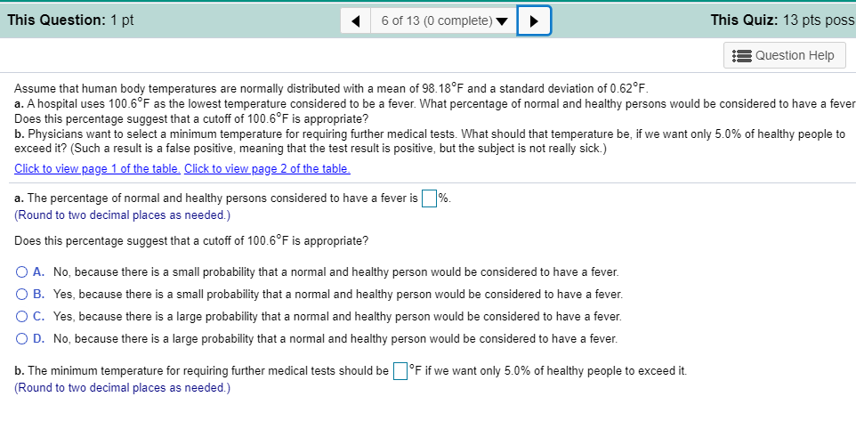

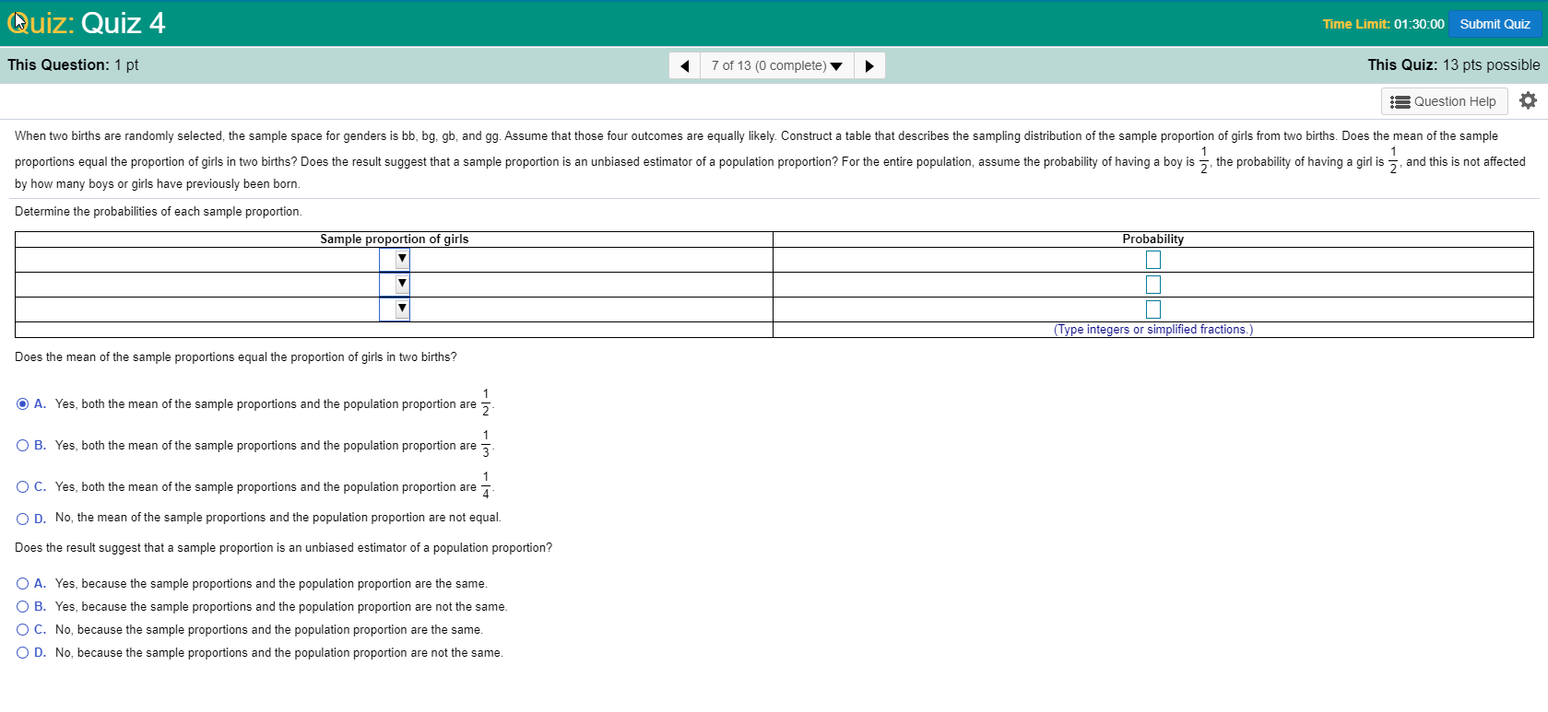

Before every​ flight, the pilot must verify that the total weight of the load is less than the maximum allowable load for the aircraft. The aircraft can carry
43 passengers, and a flight has fuel and baggage that allows for a total passenger load of
7,095 lb. The pilot sees that the plane is full and all passengers are men. The aircraft will be overloaded if the mean weight of the passengers is greater than 7,095 lb43=165 lb. What is the probability that the aircraft is​ overloaded? Should the pilot take any action to correct for an overloaded​ aircraft? Assume that weights of men are normally distributed with a mean of 180.2 lb and a standard deviation of 39.4.
The probability is approximately
.
​(Round to four decimal places as​ needed.)
Should the pilot take any action to correct for an overloaded​ aircraft?

A.
No. Because the probability is​ high, the aircraft is safe to fly with its current load.

B.
Yes. Because the probability is​ high, the pilot should take action by somehow reducing the weight of the aircraft.

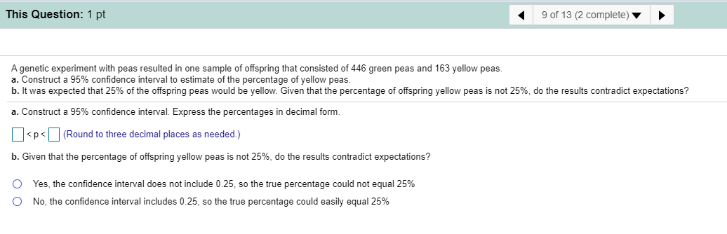

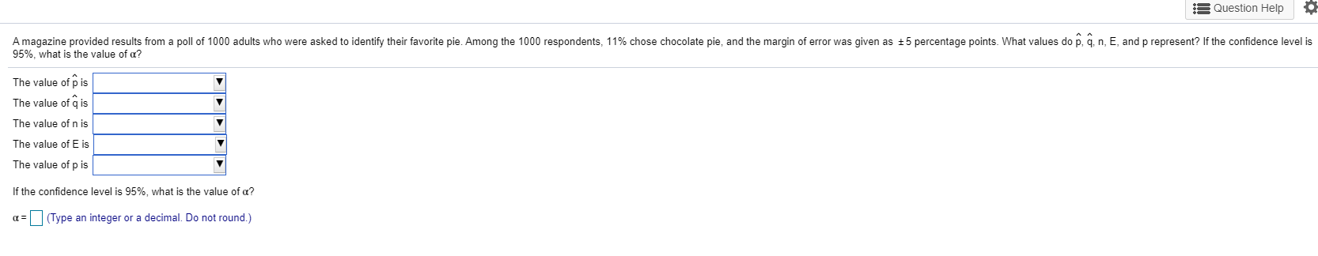

You are the operations manager for an airline and you are considering a higher fare level for passengers in aisle seats. How many randomly selected air passengers must you​ survey? Assume that you want to be 95​% confident that the sample percentage is within 5.5 percentage points of the true population percentage. Complete parts​ (a) and​ (b) below.
a. Assume that nothing is known about the percentage of passengers who prefer aisle seats.
n=
​(Round up to the nearest​ integer.)

b. Assume that a prior survey suggests that about 37​% of air passengers prefer an aisle seat.
n=
​(Round up to the nearest​ integer.)

